

Crazy Quilters Quilt Guild

We Are Crazy About Quilting

No. 396 www.crazyquilters.org January 2025

The Crazy Quilters Quilt Guild

meets the first Tuesday of the month, 7 p.m.

at Calvary Baptist Church-Allentown

[info@crazyquilters.org](mailto:info@crazyquilters.org)

[www.facebook.com/crazyquiltersquiltguildemmauspa](http://www.facebook.com/crazyquiltersquiltguildemmauspa)

**Guild Officers**

President: Jessica Dayon  
Vice-President:  Donna Gasser

Secretary:  Nancy Skok  
Treasurer:  Linda Johnston  
Programming Officer:  Sue Marin & Katrina Idleman  
Membership Officers:  Pat Piasecki & Quinn Pagano

**Guild Calendar**

**Monthly Guild Meeting:** Tuesday, Jan 7th, 7 p.m.

Faith Presbyterian Church, Emmaus

**Sit ‘n Sew:** Saturday Jan 4th & 18th at 10:15. Faith Presbyterian Church.

:

**PRESIDENT’S MESSAGE** Jessica Dayon  
  
I hope everyone had the merriest of Decembers so far! This month has flown by. I’m so sorry I was sick and unable to attend the December guild meeting. I heard that it was wonderful and enjoyed by all!

Unfortunately, my family was also sick for Christmas, so it was not an especially great time for us. As we continue to recover, I am hoping we can squeeze some of our Christmas traditions in during the remaining days of 2024.

As I get better, my mind wanders to quilting and what quilt I’ll make next. I typically make some quilting plans for the new year during the week between Christmas and New Year and I’m hoping I will be able to do that this year too. I start by looking at the quilting designs I have on my computer, as well as a ‘Quilt Board’ that I have on Pinterest, and I make plans for the ones I want to bring to life in the coming year. I also consider what skills that I want to practice and develop so that I can make sure I have quilts or projects that will make me use those skills. The list I make now isn’t the ‘end all’ list; it is a starting point. As the new year progresses, I’ll take some projects off and add some others on. It is fun planning and thinking ahead and then, knowing that if I change my mind about one of my plans, that is quite alright.

As I shared in the November newsletter also, I wanted to remind everyone that next fundraiser is in October 2025. It will be called “Crazy About Quilting”. It will consist of a quilt show, demos, and a boutique. The boutique will contain items from our sewing rooms

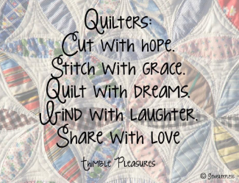

**President’s Message Continued**

that we no longer use but also a section for handmade items. It would be fantastic if you start thinking about items you can make for the boutique, like placemats, hot pads, quilted decorations, or anything clever that you can come up with. To make this event successful, we need the help of everyone in the guild.

I’m looking forward to seeing you at our January meeting!

**MONTHLY CHALLENGE**

The December challenge was to make a quilt block that you have never made before. If you participated in this challenge, bring it to the January meeting. We can show them while the votes are being tallied and after Show & Tell.

The January Challenge is to make a bag/pouch/or anything with a zipper!

**GUILD QUILT**

The guild quilt is in progress. I will work on assembling the quilt top at the January 4th Sit & Sew. If anyone would like to help, you can come to that Sit & Sew to take part.  Ruth Smith has volunteered to quilt the quilt. Kathie Laposata has volunteered to bind the quilt.

**INSTRUCTIONAL TIME AT SIT & SEWS**

There are two Sit & Sews in January: the 4th and 18th and both will be an open sews without any instructional topics.

If there is interest, I can teach a Rope Bowl instructional at the February 1st Sit & Sew. Please email me to let me know if you would be interested in participating in this event and I can provide more information.

**QUILTERS’ STUDIO**

There will not be Quilters’ Studio in January because we will meet at Faith Presbyterian for the Challenge Quilt meeting.

**Programs** Sue Marin and Katrina Idleman

January 7, 2025 – **Quilt Challenge at Faith Presbyterian,** North 2nd Street, Emmaus, PA.

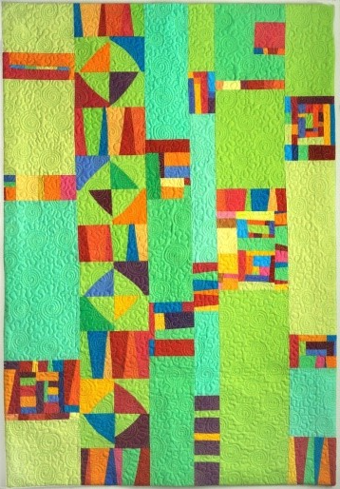February 4, 2025 – **Cindy Grisdella** shares “The Anatomy of An Improv Quilt.”

Cindy Grisdela is an artist, teacher, and author of two books on improv quilting – Artful Improv and Adventures in Improv Quilts. She will be sharing her love of color, line, and shape on February 4, 2025, via Zoom as she presents “Anatomy of an Improv Quilt “ to the guild by Zoom. Cindy’s first quilts were traditional quilts with a safe approach to color…especially the color blue! She challenged herself to expand her pallet, experimenting with color combinations that pleased her and challenging herself to use previously neglected hues. She is now known for her fearless approach to color. Her presentation will definitely brighten up a dreary February evening!

The February meeting format is hybrid. Guild members can attend in person or by Zoom. Cindy’s presentation will be by Zoom.

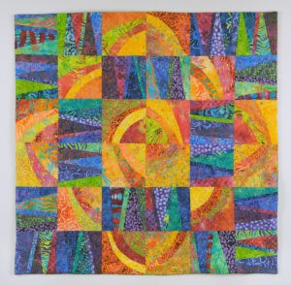

Cindy’s presentation to the guild will be followed by a half-day Zoom workshop, “Curves and Stripes”. Learn to create Improv Curves and Angled Stripes to make this cheerful wall hanging. Even if you’ve never sewed curves before, you’ll be confident in no time, because there are no pins, no templates, and no seams to match. Use your favorite colors and fabrics in solids, prints, or a combination.

Basic sewing skills and a sewing machine in good working order necessary. All levels.

Join your fellow Crazy Quilters for this half day ZOOM workshop scheduled for **Saturday, February 8, 2025.** Class will begin at 9:00 AM and end at 1:00 PM, quilters will join from home. Registration fee is $35. Please contact Sue Marin to register and send your check made payable to Crazy Quilters' Quilt Guild to Sue Registration will remain open until Friday, January 24, 2025. Class size is limited to 24 students.

Registrations will also be accepted at the January 7th Guild meeting at Faith Presbyterian Church in Emmaus. If paying in cash please bring the exact amount.

The materials and supply list will be sent to you once your payment is received.

March 4, 2025 – **Nancy Weston**, local resident and member of the Colonial Quilters, will present “HERStory Through Quilting: African American Quilting. Nancy believes the women quilters are HERstorians. Spanning Black History Month (February) and Women’s History month (March), this presentation introduces us to exhibits from the National Quilt Museum in Paducah, KY, as well as Gee’s Bend Quilting Collective in Alabama, John Lewis quilts, Bisa Butler and other modern Black quilters, and The Social Justice Sewing Academy.

Check the [website](https://www.crazyquilters.org/meeting%20and%20events.html) for additional programming.

**Quilt Challenge 2024** Irene Oehmke & Cathleen Kilpatrick

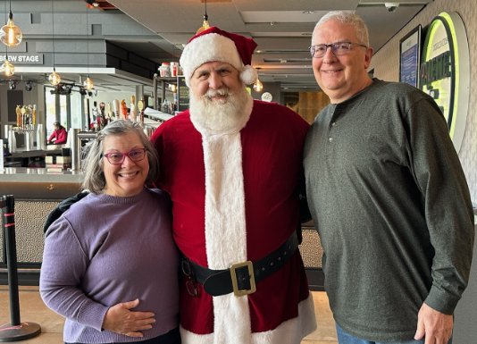It’s time! The 2024 quilt challenge will conclude at the January meeting.

I hope you all were able to open the short video of Daniel Robuck promoting our quilt challenge sent via email on Dec 8th.

Irene, Daniel Robuck & Irene’s Husband, David

**Better Done Than Perfect** Lorraine Bujnowski

We are nearing the end of a year of “Better Done Than Perfect”. There are two more months to finish your UFOs. February will be the last month for showing your quilts and the drawing will occur at that meeting.

**“Crazy About Quilts” Event**

***Ways and Means members are progressing with plans for our CQ fundraiser for next year. The “Crazy About Quilts” event will be held on Oct. 4, 2025, at Calvary Baptist Church, and it will take a lot of people to make it happen.***

***This is a wonderful chance to get to know other Guild members, as several people will be involved in each committee.***

***You all have an aptitude, skill, and/or talent that can help make this event a success. Your abilities may be the one segment of a committee that is needed to make things run smoothly.***

***Please refer to the separate flyer which is included with the newsletter. It explains the different aspects of all committees. We will begin asking for sign-ups at the January meeting.***

**Hospitality** Diana DeFanti & Sandy O’Connor

On December 3rd our quilt members gathered for our annual potluck dinner where a delightful variety of hot and cold dishes were presented and served. In addition, there was an impressive selection of 14 desserts. After the meal, the evening continued with 4 members sharing their special quilting projects showcasing their creativity and skill.

Sandy and I appreciate all the assistance in preparing and organizing the evening ensuring a memorable event for everyone.

January 7th 2025 members who signed up to bring an item for the food table are: Kim Carlo, Nancy Skok, Quinn Pagano. We would like two more volunteers. If others have leftover cookies from the holidays, a dozen or so will be appreciated to add to the table. Any questions or concerns, please contact Sandy O’Conner at or email

**2024 Round Robbin**

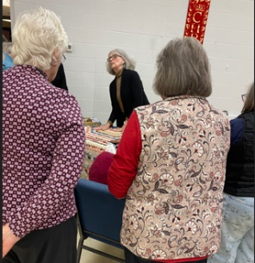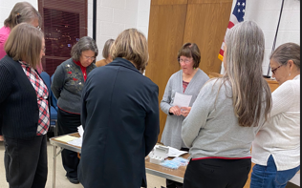

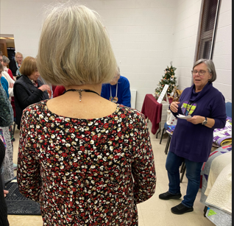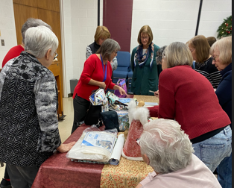

Sharon Yurkanin - Miniature EPP and Reproduction Fabrics

Pat Wolfe - Multigenerational Keepsake Quilt Using Tsukineko All Purpose Inks

Cathleen Kilpatrick - Modern Influences

Sandy O'Connor - Handbags

**Library Trolley** Michele McLaughlin  
  
Anyone with a library suitcase, please bring to the February meeting.  February will be the perfect time to complete the book sale.

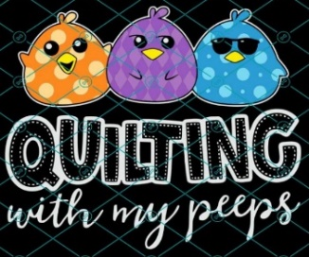**Sit ‘n Sew** Linda Wojciechowski   
  
 Mark your calendar for **Saturday January 4, & 18, 10:15 a.m. to 4 p.m.,** at Faith Presbyterian Church, Emmaus. The Sit ‘n Sews will be on the 1st & 3rd Saturdays of each month unless notified otherwise.

Bring your quilt project, sewing machine and quilting supplies and your lunch. And don’t forget an extension cord and light. An iron and ironing board are provided, but you may also bring a small iron for use at your station.   
 **Text or call me at 610-360-8693 by noon the day before to reserve your spot,** and please be prepared to help set up and store tables. I look forward to seeing you there!

**Community Service** Janet Yandrisevits & Mercedas Gurniak

Getting ready for the Holidays may have taken many of us away from our sewing projects, and also sent others to their sewing in order to complete gifts for our loved ones. As the weather turns colder, we all may enjoy a return to our favorite hobby to help us feel cozy.

Wishing everyone a hopeful and Happy New Year!

**Membership** Pat Piasecki & Quinn Pagano

There were 54 members who attended the December meeting. A visitor, Lynda York, joined. This brings us up to 87 paid members. Fifteen members have not renewed membership.

***Birthday wishes for January to members:***

|  |  |  |  |  |  |  |  |  |  |  |  |  |  |  |  |  |  |  |  |  |  |  |  |  |  |  |
| --- | --- | --- | --- | --- | --- | --- | --- | --- | --- | --- | --- | --- | --- | --- | --- | --- | --- | --- | --- | --- | --- | --- | --- | --- | --- | --- |
| |  |  |  | | --- | --- | --- | | VERHELLE | JAN | 4-Jan | | LEIPERT | JACKIE | 5-Jan | | MURRAY | LAURIE | 8-Jan | | ROSSETTI | JANIE | 12-Jan | | BUJNOWSKI | LORRAINE | 19-Jan | | STEIN | LORI | 20-Jan | | NELSON | SUZANNE | 24-Jan | | VESHINFSKY | DEB | 25-Jan | |  |  |
|  |  |  |
|  |  |  |
|  |  |  |
|  |  |  |
|  |  |  |
|  |  |  |
|  |  |  |
|  |  |  |
|  |  |  |

**

**Committees**

**Challenge**: Irene Oehmke & Cathleen Kilpatrick

**Community Service**: Janet Yandrisevits and Mercedes Gurniak

**Fundraising & Ways & Means:** Donna Gasser, Julie McDonnell, Pat Piasecki, Jane Merkel, Cathleen Kilpatrick, Gail Shearer, Sue Marin

**Guild Quilt Construction:** Jessica Dayon

**Historical**: Kathy Moore

**Hospitality**: Diana DeFanti & Sandy O’Connor

**Library**: Michele McLaughlin

**Newsletter**: Karen Rush

**Publicity**: Linda Wojciechowski

**Quilters Studio**: Julie Borden & Jessica Dayon

**Retreat**: Sandy O’Conner

**Show and Tell**: Suzanne Nelson & Judy Walker

**Sit & Sew**: Linda Wojciechowski

**Sunshine and Shadows**: Linda Anderson

**Technology:** Kim Bringhurst, Katrina Idelman, Cathleen Kilpatrick, Jane Merkel, Gail Shearer

**Website**: Nancy Scholz



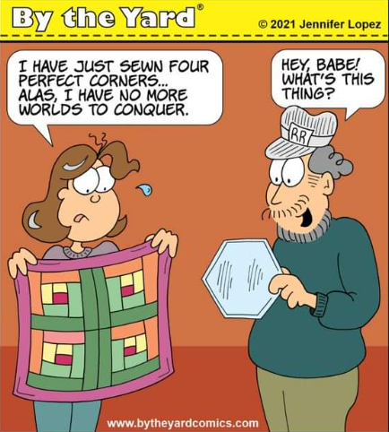

Upcoming Events

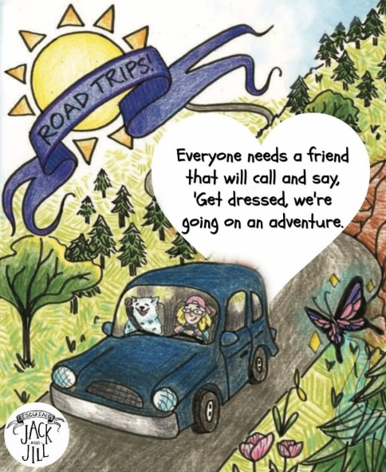**2025**

**Now through March 2nd, 2025** – [Chester County History Center](https://mycchc.org/), “Signature Quilts”.

**January 4th** – Quilters Giveaway, 9 a.m. to 3 p.m. at Holy Cross Evangelical Lutheran Church, 2700 Jacksonville Rd, Bethlehem

**February 8th – ZOOM** workshop with Cindy Grisdella, “Curves and Stripes”, 9 a.m. – 1 p.m.

**February 27 – March 2 –** [Mid-Atlantic Quilt Festival](https://www.quiltfest.com/upcoming-shows-and-events/mid-atlantic-quilt-festival/), Hampton Roads Convention Center, 1610 Coliseum Dr, Hampton, VA

**March 7 & 8** – [Susquehanna Valley Quilt Guild](https://susqvalleyquilters.org/) “Valley in Bloom”. Warrior Run Area Fire Dept, 1st Street, Allenwood, PA.

**March 26-29** – [The Lancaster Quilt Show at Lebanon Valley](https://www.aquiltersdestination.com/lancaster-pa?utm_source=lancasterpa.com&utm_medium=referral&utm_campaign=Lancasterpa), Lebanon Valley Expo Center.

**May 3 –** [Airing of the Quilts](https://www.theairingofthequilts.com/), Palmerton, PA

**May 3 & 4** – Global Quilt Connection Sample Platter

**June 26-28** – [Road to Virginia](https://www.road2va.com/), Greater Richmond Convention Center, Richmond, VA

**July 17-19** – [The North East Ohio Quilt Show,](https://www.aquiltersdestination.com/ne-ohio-show-info) Wayne County Fair Event Center, 199 Vanover St, Wooster, OH

**September 6 & 7** – Schuylkill County Quilters Guild, Quilt Spectacular 2025 – Winter Whimsy, Walk In Art Center, 220 Parkway, Schuylkill Haven, PA.

Third Saturday of the Month, Fiber Art Sit & Sew, Parkland Community Library, 9 a.m. – 12:30 pm. RSVP to the Library.

**Workshops highlighted in red are Crazy Quilter Guild events.**

**If you discover any events to be added, please send to Karen.**

After much consideration and careful evaluation, the Board of Directors for the Kutztown Folk Festival has announced that its nine-day summer event will not be held in 2025. This decision comes as a result of mounting financial challenges that have made the event unsustainable. [LINK to the full article](https://www.bctv.org/2024/11/21/kutztown-folk-festival-will-not-return-in-2025-due-to-economic-constraints/#:~:text=After%20much%20consideration%20and%20careful,have%20made%20the%20event%20unsustainable.).