Crazy Quilters Quilt Guild

We Are Crazy About Quilting

No. 324 www.crazyquilters.org October 2018

The Crazy Quilters Quilt Guild

meets the first Tuesday of the month, 7:00 PM

except November at

The Lutheran Church of the Holy Spirit

3461 Cedar Crest Boulevard

Emmaus, PA

[info@crazyquilters.org](mailto:info@crazyquilters.org)

[www.facebook.com/crazyquiltersquiltguildemmauspa](http://www.facebook.com/crazyquiltersquiltguildemmauspa)

Works by the Crazy Quilters Quilt Guild

Sharon Yurkanin

Our quilt exhibition, **Works by the Crazy Quilters Quilt** **Guild**, at the Allentown Art Museum is approaching.  The dates are November 11 – December 30. Quilt selection will take place at our October 2 meeting.  We will be accepting your quilts from 5:00 until 6:30 in room 117/119, next to the kitchen.  Selection will take place at 6:30. All quilts are to be taken home after the meeting that evening.

We have been especially careful to keep the entire process of quilt selection anonymous. Selectors don’t know whose quilts they are looking at and all quilts are returned that evening with an envelope containing a letter.  No one will know but you whether your quilt has been selected.

The selection committee will be looking for a variety of styles, workmanship, overall design, bindings, etc.  Around 5 bed sized quilts will be accepted due to space limitations, so keep that in mind.

Quilts that have been selected will need to be delivered to Sharon Yurkanin at the Allentown Art Museum by November 4.  Call Sharon if you need to make other arrangements.

If you would like to demo some handwork at the exhibit contact Julie Borden. The hours are 12-4 on November 11th.

Thank you all for sharing your best work with the community in this way!

From The President Julie McDonell

I hope everyone enjoyed Joyce Hughes. Even if you’re not into thread painting, she certainly had interesting - and fun - examples of her work. It’s unfortunate that our agenda was so full that night, as I believe many of us would have liked to take more time with her.

I also had to rush the induction of our new officers. I welcome those new to the Board. Fresh perspectives are what help keep our guild vital and productive. And ongoing ideas from ALL members are always beneficial and appreciated.

As noted at the meeting, the Kemerer Museum in Bethlehem contacted us because they have some nice crazy quilts. Anyone else interested in being a tour guide, contact Kelly at ksanders@historicbethlehem.org. (There will be a short training session.)

Friends and I have complained how, as we age, time seems to fly by quickly.



I just read that the reason is because our brains mark time by the new memories being made. When young, this happens all the time. However, as we age we often settle into more of a routine, so our days begin to blur together. The solution is to do something new and different to create new experiences.

Therefore, I’m embracing this as my reason for starting new projects, to slow down time. Next all I need is an excuse - oops I mean reason - for not getting around to finishing them.



Programs and WorkshopsNicole Folino

On Tuesday, October 2, 2018 at 7 PM at Holy Spirit, guest speaker Kathryn Jenson White will present quilts from her collection of Alphabet Quilts.

Join us to hear Kathryn speak about her 30 years of quilting and her love of the word/idea of **TEXTiles**. With wonderful storytelling, experience and myriad of over 50 alphabet inspired tops and quilts in this trunk show, you won't want to miss it.

A B C-you there!

Sit & Sew Laurie Murray and Helen Hanton

Sit & Sew in September will be on September 22, from 10:15 AM until 4 PM at Faith Presbyterian Church, Emmaus. Please note this is NOT the Saturday following our regular guild meeting. All are welcome. Bring you projects to sew, cut, and layout. There is plenty of room to spread out and work.

Sit & Sew in October will be the Saturday following the guild meeting, October 6, from 10:15 AM until 4 PM at Faith Presbyterian Church, Emmaus.

Community Service Kathie Laposata

October is Breast Cancer Awareness month, which makes our collection of breast cancer pillows very timely. I think you all know survivors of breast cancer or are a survivor yourself, and these pillows make recovery from mastectomies a little more comfortable. Directions are on the Guild’s Community Service website. Make some in honor of someone you know. Read some testimonials at this website to see how much they are appreciated. <http://moonlightpillows.com/category/testimonials/>

Since we don’t have a November meeting, I’m hoping you will overwhelm me with Meals on Wheels placemats at our December meeting. If you can’t make that meeting, contact me and perhaps we can meet individually before the meeting date to see that I have them in time to deliver to Meals on Wheels in early December. They are so appreciated by the homebound clients of this organization. They are a great way to use project leftovers, orphan blocks and fabric that is no longer loved.

Library Michele McLaughlin and Dawn Martrich

Carol Willis has volunteered to bring the raffle basket to the October meeting!  Thanks from Michele and Dawn

Show and Tell Lorraine Bujnowski and Roberta Whitcomb

The following members participated in Show and Tell on September 4, 2018:  Wendye Anttila (3), Valerie Barber, Julie Borden, Lorraine Bujnowski, Julie Davidovich, Diana DeFanti, Jane Merkel, and Sandra Mugridge (2).

Quilters Studio Julie Borden

We had a great turn out for our Labels, Labels, Labels discussion.  The majority of quilters in our discussion group do not religiously label their quilts, so the outcome of our meeting was to go home and add labels to our existing quilts, and moving forward be better at documenting our work.

**Quilters Studio will not meet in October due to the collection of quilts for the Allentown Art Museum quilt exhibit, or in December because of the potluck. Also, there is no meeting in November because the church is a polling site.** We will meet at 5:30 in both January and February, and I am looking to sharing what is of interest to you.  Please send your ideas to me at hedthread@yahoo.com.

Hospitality Diana DeFanti

The September ice cream social with our scrumptious anniversary cake was enjoyed by all the members. Thanks to Sandra Mugridge and Nancy Skok for assistance.

**October volunteers** are Jane Merkel, Nancy Ayers, Irene Magdalena, Sandra Mugridge, Nancy Skok, Pat Cisek and Roberta Aeschliman. A reminder will be sent the week prior to the meeting.

Membership Janet Yandrisevits and Janet Tryson

Our September meeting had 64 members in attendance and three visitors.  Our visitors were Lynda Wagner, Dianne Green, and Donna K. Mabus.  We welcomed Roberta Aeschliman as a new member; she was a visitor with us at our August meeting. She is an intermediate quilter who heard about us from a friend, an office assistant for 20+ years, has a farming background and is retired military.

Twenty six members renewed their membership for the 2018-2019 year and renewal of dues for the upcoming year will continue to be accepted at the October meeting.  Membership cards will be distributed to you at the October meeting if you did not receive yours at the September meeting.  We will resume our prize drawing for wearing your name tags at our October meeting.

We would like to add a special thank you to Judy Walker for helping Janet Y. at September's meeting.

October Birthdays  **  **

2   Lois Drendall 5 Ann Lineberger 14 Roberta Aeschliman

3   Leah Gehman 12 Doris Horwath 14 Nancy Keeler

4   Michele McLaughlin 13 Lynnda Cromeans 24 Maria Hance

4   Roberta Whitcomb 13 Nancy Scholz 29 Patricia Piasecki

29 Judy Walker

Modern Bee Nicole Folino

The Modern Bee meets once a month, the last Wednesday of the month, alternating mornings and evenings to accommodate all of our members who are interested in attending.  You many attend some, any, or all of the meetings, mornings and/or evenings at your convenience.  Locations will be announced in the newsletter.  We have Show and Tell, talk modern quilt aesthetics of design and color, etc., sew, snack, and converse.  Bring your machine or handiwork and a packed lunch or dinner, if you wish.

On September 26, we will be taking a **modern fabric field trip**.  We will meet at Wegmans, 3900 Tilghman St, Allentown, by the cafe entrance at 9:00 AM, and head to the brand new shop, Stitch Central, in Huntington Valley and then The Round Bobbin, Ambler.  We will then get lunch at Lily's in Doylestown and finish at The Sewing Room. Please RSVP to me by September 24.  Depending on attendance we may need additional drivers.

Raffle Quilt Marketing Samantha Cetrulo

I had the pleasure of attending the great Allentown fair this year for the first time.  We sold raffle tickets 2 nights and the total was $176.  I enjoyed looking at all the different items entered in the fair.  I got excited every time I saw a name from the guild I recognized.  Some guild members and their winning quilts from the fair are pictured here.

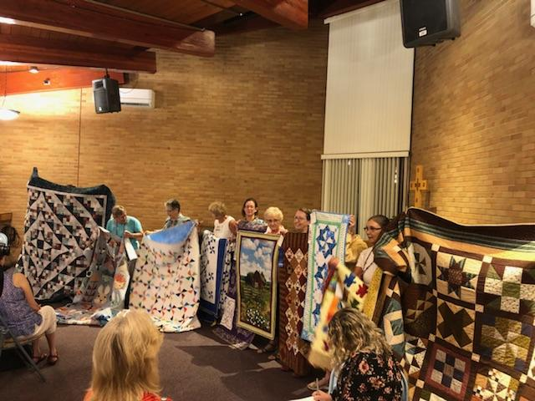

Another benefit to the show was getting out our guild name. Upcoming events for the raffle quilt include Lancaster Modern Quilters Bazaar on September 29 and the Macungie Farmers Market on October 4.

Panel Play 2018 Challenge Jane Merkel

I handed out forms for those of you planning on entering the challenge.  I would really like to have a ball park figure of how many of you will participate and what kind of space requirements we need the night of the challenge.  Please help me out here!!  Either e-mail me with your tentative project type and size or pick up the form at the October meeting and return it to me that night.

I really appreciate your participation and am looking forward to a lot of interesting projects. Our September program was wonderful and may give you additional ideas, so it is not too late to enter.  If you really get inspired after that, just call me with the details. Happy sewing.

Member Retreat Sandy O’Conner

There are 17 members signed up to go in to the retreat in November. There is room for 20 participants, so if no one else signs up by September 15, sign-ups will open to a couple people who went in the past and have expressed an interest in going.

Also, I’ll send participants a list of all attendees with email addresses included, so we can make plans for meals which are Friday dinner, Saturday brunch, Saturday dinner and Sunday brunch. I’ll also send driving directions.

Member News and Requests

Allentown School District Liaison Project Marsha Heimann

Thank you to everyone who brought in toiletries at the August Quilt Guild Meeting and to Ruth Skinner and Debbie Heeps who have provided a “ton” of toiletries from all their travels. As I continue to make the drawstring bags I need your help to collect toiletries so they can be filled. These Christmas bags are for the Allentown School District Homeless Kids Project. There are over 600 Homeless children in the school district and we would like to provide as many of these small gifts as possible. For many, this is the only gift they receive at Christmas time. If you have small travel size toiletries such as toothpaste, deodorant, shampoo, conditioner, lotion or anything small and not used tucked away from your hotel stays or pick up a few small hygiene items in the travel section at your grocery store or Target, Walmart, CVS, etc. please consider bringing them to a guild meeting. There will be a basket located on the registration table with a sign for you to place them. We will be collecting until the November meeting to fill the bags. Please take a look in your linen closet, bathroom drawers or even your suitcases and see if you have some small bottles tucked away. I am grateful for your support. Thank you.

Stamps for the V.A. Mercedas Gurniak

Please bring cancelled stamps, **with ¼ inch of the envelope remaining around the stamp**, for the V.A. The stamps are used to decoupage items for sale in the gift shop.

Yarn for Cedarbrook Ruth Skinner

I am still accepting yarn of all size skeins or balls to make shawls for Cedar Brook Nursing Home residents.

Homemade Spray Baste Ruth Skinner

Ruth recommends this item about how to make a basting spray.

<https://www.stringandstory.com/blog/2017/2/14/tips-tuesday-homemade-spray-baste?utm_source=newsletter&utm_medium=email&utm_campaign=do_you_sew_or_quilt_with_your_families&utm_term=2018-07-27>

See page 5.

Guild Calendar from the editor

Saturday, September 22 - **Sit & Sew,** 10:15 - 4, Faith Presbyterian Church, Emmaus

Saturday, October 6 – **Sit & Sew,** 10:15 – 4**,** Faith Presbyterian Church, Emmaus

Wednesday, September 29 - **Modern Fabric Field Trip**

October 2 - **Guild meeting**, 7 PM, The Lutheran Church of the Holy Spirit, Emmaus

November 11- December 30, **Works by the Crazy Quilters** **Quilt Guild**, Allentown Art Museum

Guild Officers

**President**: Julie McDonell

**Vice President**: Barb Kissell

**Secretary**: Denise Riemer

**Treasurer**: Kathy Moore

**Membership Officers**: Janet Yandrisevits and Janet Tryson

**Programs Officer**: Nicole Folino

Committee Chairs

**Allentown Art Museum Exhibit**:Sharon Yurkanin

**Challenge**: Jane Merkel

**Community Service**: Kathie Laposata

**Communication Chain**: Diane Pesola

**Historical**: Rhonda Moore

**Hospitality**: Diana DeFanti

**Library**: Michele McLaughlin and Dawn Martrich

**Modern Bee:** Nicole Folino

**Newsletter**: Kathy Schuessler

**Publicity**: Linda Wojciechowski

**Quilters Studio**:Julie Borden

**Quilt Raffle Marketing**: Samantha Cetrulo

**Raffle Quilt Creation**:

**Retreat**:Sandy O’Conner

**Show and Tell**: Lorraine Bujnowski and Roberta Whitcomb

**Sit & Sew**:Laurie Murray and Helen Hanton

**Sunshine and Shadows**: Sandra Mugridge

**Website**:Nancy Scholz

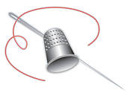

Calendar of Eventsfrom the editor

October 5-6, Berks Quilters Guild, Quilt Show 2018, Leesport Farmers Market, [www.berksquiltersguild,org](http://www.berksquiltersguild,org).

October 5-6, Peaceful Shores Quilters Guild, Shore Points 25 Quilt Show, Ocean Acres Community Center, Manahawkin, NJ, visit their Facebook page, Pieceful Shores Quilters Guild.

October 20-21, Brandywine Valley Quilters Quilt Show, The Brookhaven Municipal Building, Brookhaven, PA [www.brandywinevalleyquilters.com](http://www.brandywinevalleyquilters.com).

November 2-17, 16th Annual Eastern PA Shop Hop,

Facebook.com/EasternPAShopHop.

November 9-10, Lebanon Quilters Guild 12th Annual Exhibition of Quilts, Lebanon Expo Center & Fairgrounds, [www.lebanonquiltersguild,com](http://www.lebanonquiltersguild,com).

November 17, Mail Line Quilters, Quilt Show and Holiday Boutique, Berwyn United Methodist Church

February 28 - March 3, 2019, Mancuso Mid-Atlantic Quilt Festival, Hampton, VA, [www.quiltfest.com](http://www.quiltfest.com).

March 27-30, 2019, AQS Quilt Show, Lancaster County Convention Center, 25 S. Queen St, Lancaster, PA, [www.quiltweek.com](http://www.quiltweek.com).

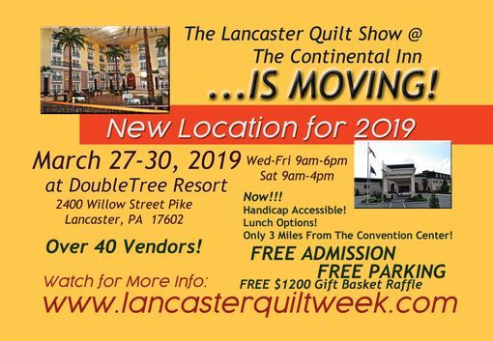



Fabracadabra

[fab-ruh-kuh-dab-ruh]

**noun**

a mystical word or expression used when fabric magically appears in your stash that you forgot buying, hid under the stairs, or stashed under you bed months ago.